**SWE 645 :- Project 4**

**Autors: Ajit & Haramrit(G0210173,G01229319)**

**Project Link:-** <http://ajitdmyadav1.s3-website-us-east-1.amazonaws.com/>

**Prerequisite:-**

1. **Angular App**
2. **Aws account**
3. **Lamda**
4. **Dynamo DB**
5. **Api gateway**

**Step1:-**

**Do “Ng build prod” on the angular app now your folder should create a dist folder in which all your production files are present these are the files that are to be uploaded in the S3 bucket at AWS for static we hosting.**

* 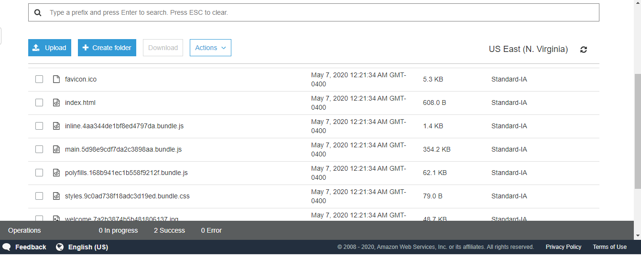Now login to AWS account and select S3 in that Select your bucket and upload the files in the dist folder.

Once the files are uploaded select the permissions and enable all the access to the S3 bucket.

Now go to the link on the endpoint of AWS and check whether the website is available or not .

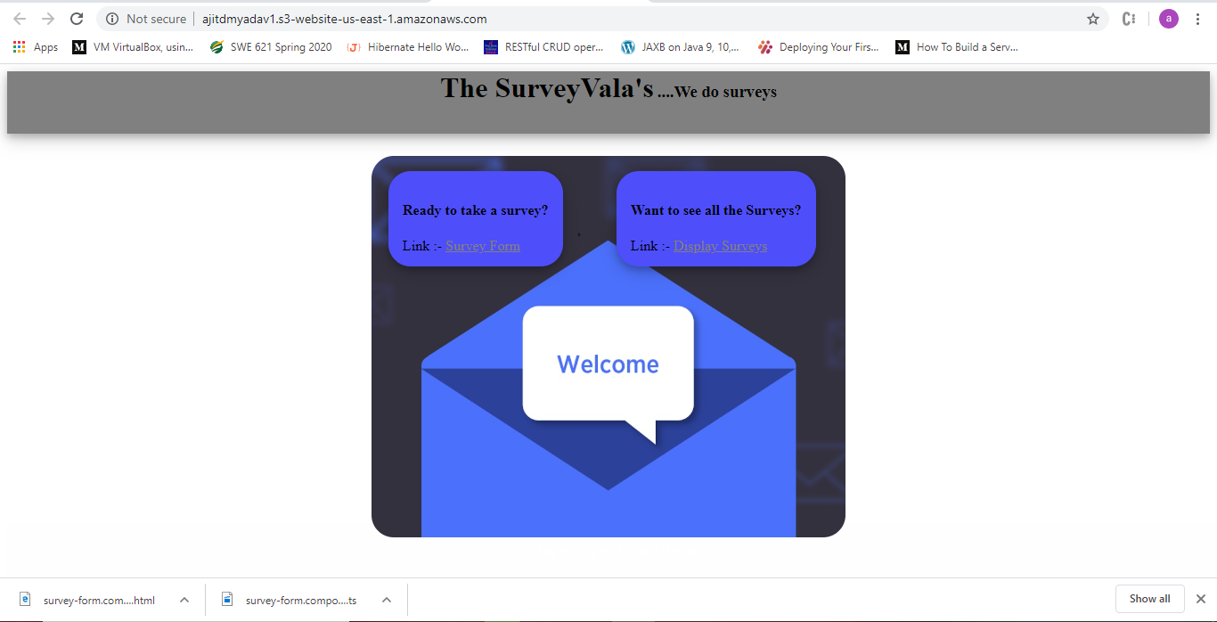

Displaying the Records.

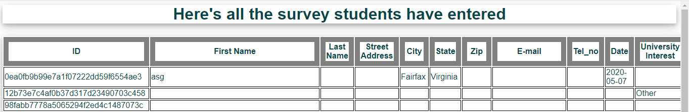

Form page:-

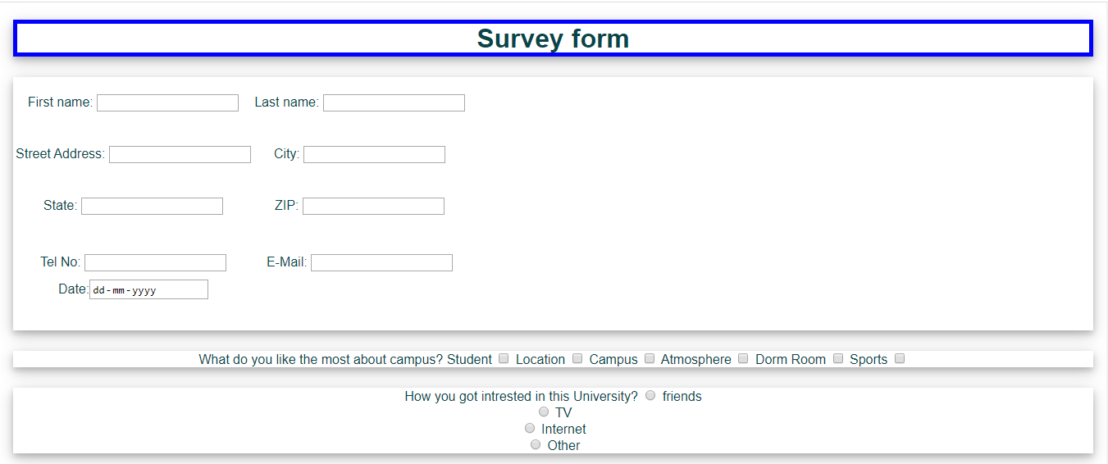

**Step 2:- Creation of the Database Dynamo DB:-**

Select the Create table icon on the DynamoDB page then you can see the created table named “Survey” in the diagram below.

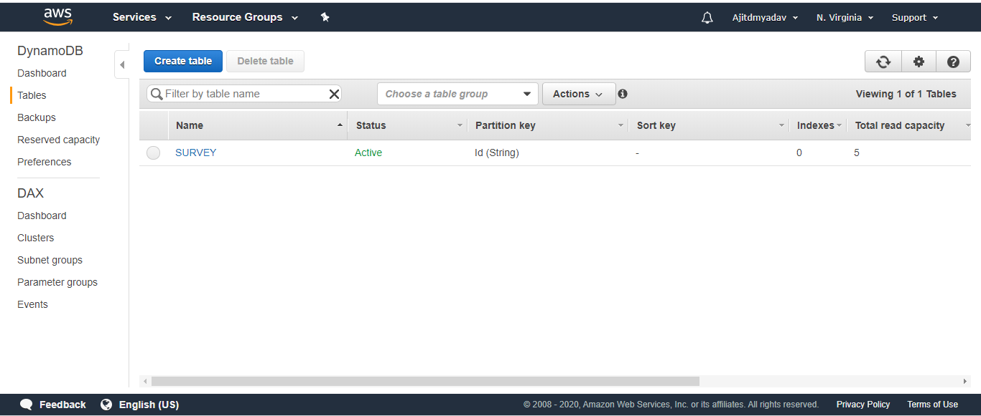

* Clicking on the DB name we can see the following information

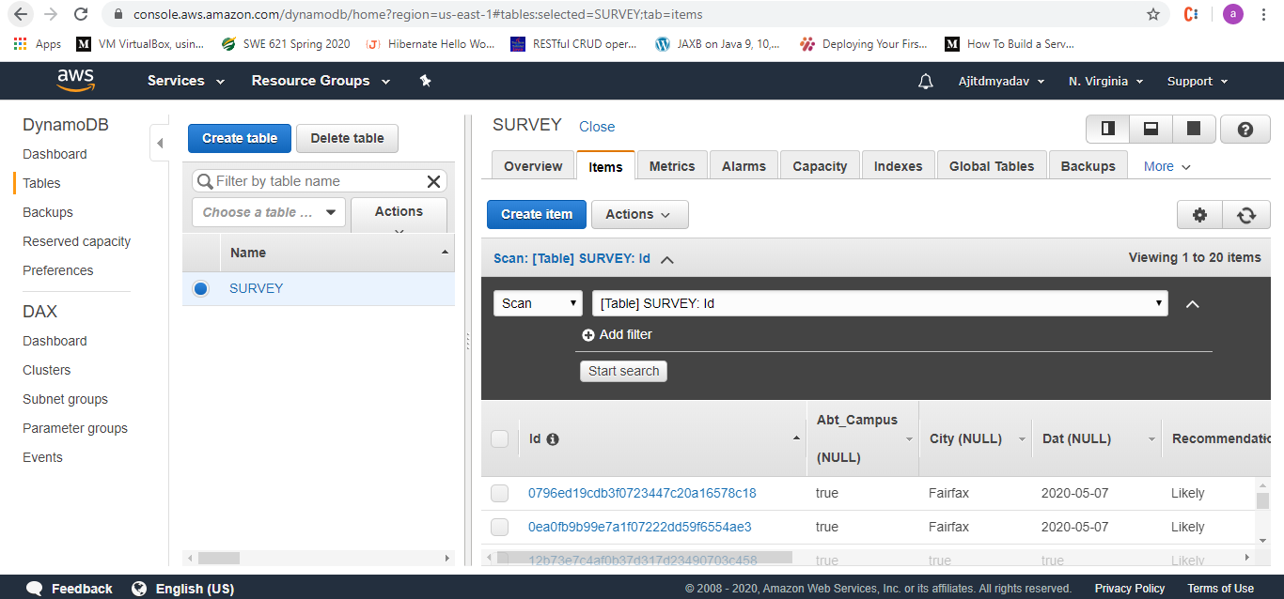Once the Database is created and working fine we can now go to next step.

**Step 3:- Now Creating the Lamda function which will interact with the database and also revert with the data to the Web app.**

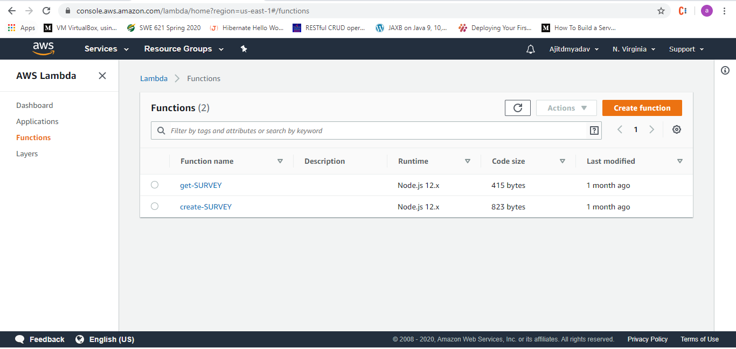

**Clicking on the Create function we can create the functions as per our needs like in this case I have created 2 function one for getting the data from the user and the other for inserting the data into database.**

**Here we have used Node js for the database connectivity.**

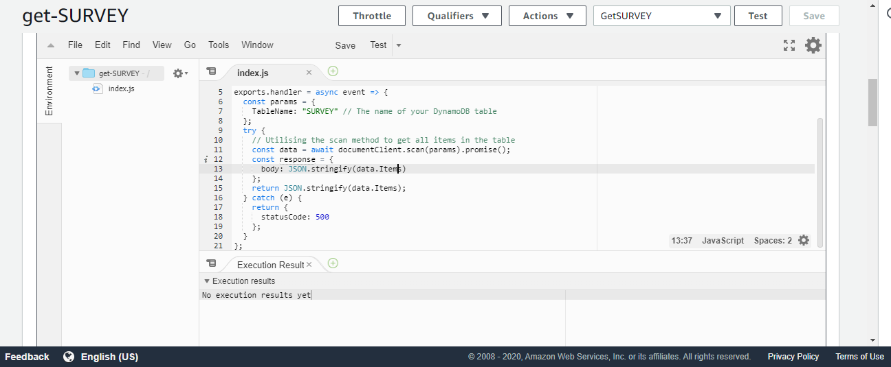

Create survey function:-

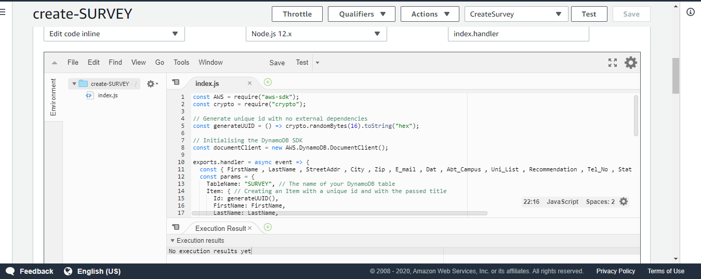

Once we have the lamda function connect with the database and S3 as the static website the only last thing remaining is the API gateway which will form the entry point for the website to the app.

**Step 4:- Creating the API GATEWAY :-**

**Click on the API gateway from the services link in the AWS**

**You should see the output as below on that click on the create api option and we can not create the required api in which we’ll be handling the GET and POST request.**

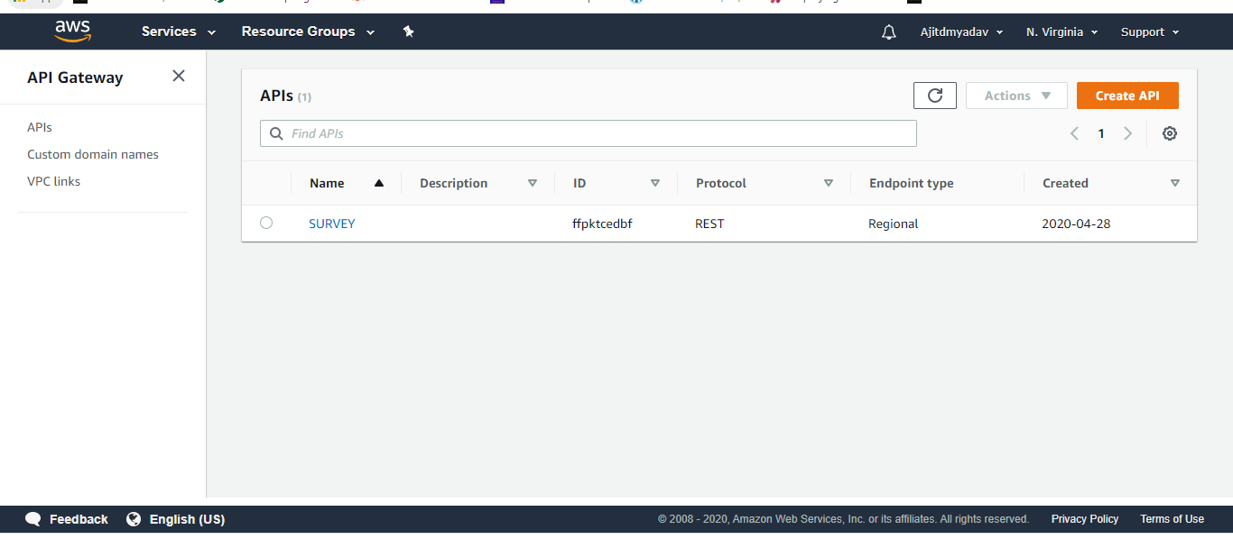

**The diagram below shows the whole architecture:**

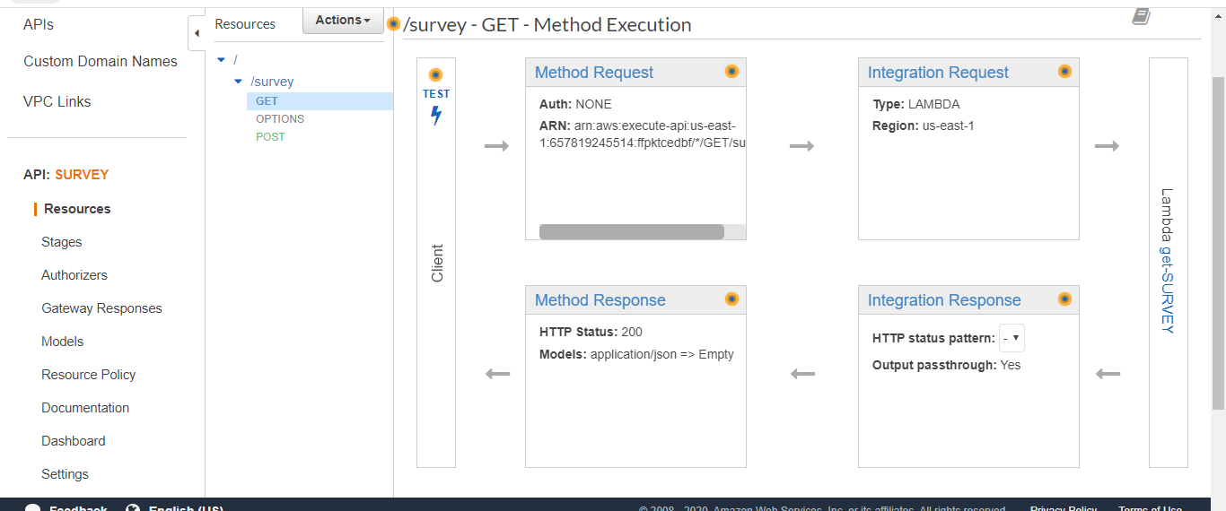

**And Done.**

**-------------------------------------------------Thankyou------------------------------------------------------------**